**B.TECH VI SEMESTER**

**SESSION 2020-21**

**POWER ELECTRONICS**

**Laboratory Manual**

## 

## Department of ECE

***MAHILA ENGINEERING COLLEGE AJMER***

AJMER-RAJASTHAN(305002)

**MAHILA ENGINEERING COLLEGE AJMER**

(Approved by A.I.C.T.E and Affiliated to BTU)

Ajmer,Rajasthan-305002.



**Power Electronics Lab Record**

## CERTIFICATE

**This is to certify that it is a Bonafide Record of practical workdone in the Power Electronics Laboratory in VI sem of III Year during the session……………**

**Name:……………………………………………**

**Roll no:………………………………………….**

**Course:B.Tech……..Year…… Semester…………**

**Branch: ……………………………………………**

**SIGNATURE OF FACULTY/STAFF MEMBER**

# INDEX

|  |  |  |  |
| --- | --- | --- | --- |
| **SI.NO:** | **DATE** | **EXPERIMENT** | **SIGNATURE** |
|  |  |  |  |

## CONTENTS

**Experiment No**

1. SCR Characteristics
2. RC Triggering Circuit – HWR & FWR
3. UJT Triggering of SCR
4. UJT Triggering of SCR – HWR & FWR
5. TRIAC Characteristics
6. AC Voltage control by using TRIAC & DIAC
7. Pulse Width Modulation techniques
8. Single Phase Dual Converter
9. Single Phase Cyclo Converter
10. Speed control of a 1  Induction motor

##### Circuit Diagram: -

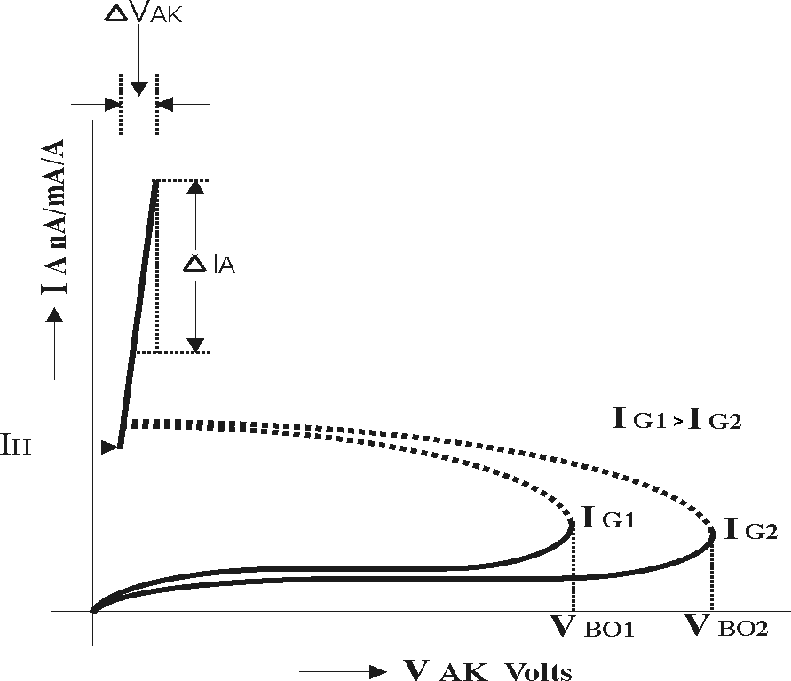

I L > I H

**IL > IH**

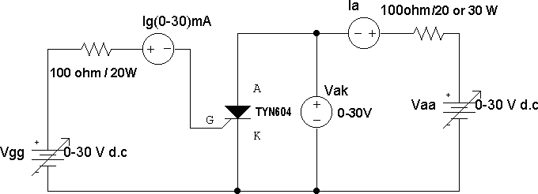

I K  / I W

1 K  / 1 W

**Ideal Graph: -**

**I L I H**

**Base Diagrams of 2N3669/70 & TY604: -**

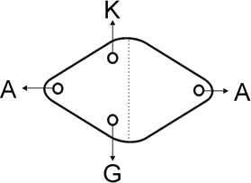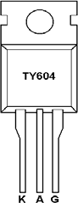

**Experiment No: 1** **DATE:**  **/**  **/**

**S.C.R. Characteristics**

**Aim: -**

To study the V-I characteristics of S.C.R. and determine the Break over voltage, on state resistance Holding current. & Latching current

##### Apparatus required: -

SCR – TY604, Power Supplies, Wattage Resistors, Ammeter, Voltmeter, etc.,

##### Procedure: -

* 1. Connections are made as shown in the circuit diagram.
  2. The value of gate current IG, is set to convenient value by adjusting VGG.
  3. By varying the anode- cathode supply voltage VAA gradually in step-by- step, note down the corresponding values of VAK & IA. Note down VAK & IA at the instant of firing of SCR and after firing (by reducing the voltmeter ranges and in creasing the ammeter ranges) then increase the supply voltage VAA. Note down corresponding values of VAK & IA.
  4. The point at which SCR fires, gives the value of break over voltage VBO.
  5. A graph of VAK V/S IA is to be plotted.
  6. The on state resistance can be calculated from the graph by using a formula.
  7. The gate supply voltage VGG is to be switched off
  8. Observe the ammeter reading by reducing the anode-cathode supply voltage VAA. The point at which the ammeter reading suddenly goes to zero gives the value of Holding Current IH.
  9. Steps No.2, 3, 4, 5, 6, 7, 8 are repeated for another value of the gate current IG.

##### Designing Equations:-

**Wkt,**

Vaa

Ia RL

Vscr

Let Ia = 300mA

Vscr = 1v Vaa = 30v

R  Vaa  *Vscr*

*Ia*

L

##### Wattage:-

*RL* 

30 1

300103

 96.66  100

Power in watts = I2RL = (300x10-3)2x100 = 9 watts (select 20 watts)

Load resistor = RL = 100, 20watts

##### Gate Resistance (Rg):-

**Wkt,**

Vgg

Ig R g

Vgt

Let Ig = 15mA

Vgt = 1v Vgg = 15v

R  Vgg  *Vgt*

*Ig*

g

##### Wattage:-

*Rg* 

#### 15  1

15 103

 933  1X 

Power in watts = I2Rg = (15x10-3)2x103 = 0.225w (select 1 watt)

Gate resistor = Rg = 1K, 1 watts

##### Note: - Follow the same design procedure for TRIAC connection sting

Latching Current



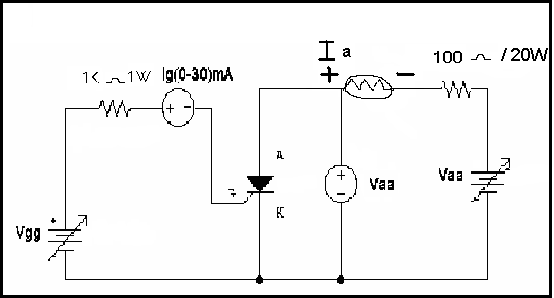

**Alternate Method: -**

1. Connections are made as shown in the circuit diagram
2. Adjust the value of Ig to zero or some minimum value
3. By varying the voltage Vak from 0 to 10 volts with a step of 2 volts, note down corresponding values of Ia
4. Now apply the gate voltage gradually, until SCR fires, then note down the values of Ig and also the values of Ia and Vak
5. Increase Vaa to some value and note down Ia and Vak
6. Reduce gate voltage to zero, observe ammeter reading by reducing Vaa which gives the values of Ih (holding current) at the point at which, current suddenly drops to zero
7. Repeat the steps 2, 3, 4, 5 & 6 for different values of break over voltage
8. Plot a graph of Vak v/s Ia
9. The on state resistance can be calculated from the graph by using formula,

RON - STATE  VAK 

IA

##### Tabular column: -

**Ig =**  **mA** **Ig =**  **mA**

|  |  |  |
| --- | --- | --- |
| Sl.No | VAK Volts | IA A/mA/A |
|  |  |  |

|  |  |  |
| --- | --- | --- |
| Sl.No | VAK Volts | IA A/mA/A |
|  |  |  |

**Procedure (Latching current)**

1. connections one made as shown in the circuit diagram
2. Set Vgg at 7 volts
3. Set Vaa at particular value, observe Ia, by operating the switch (on & off). if in goes to zero after opening of the switch, indicates Ia < IL
4. Repeat step 3 such that the current Ia should not go to zero after opening of the switch. Then Ia gives the value of IL.

##### Viva questions: -

1. Explain the working operation of VI characteristics of S.C.R.
2. Define Holding current, Latching current on state resistance, Break down voltage
3. Explain the working operation of S.C.R. characteristics by using two transistor analogy
4. Write an expression for anode current
5. Mention the applications of S.C.R.?

………………………….…………………….. Signature of the staff with date

##### Experiment No: 2 DATE: / /

**RC Triggering Circuit – HWR & FWR**

**AIM: -**

To study the performance & waveforms of HWR & FWR by using RC triggering Circuit

##### APPARATUS REQUIRED: -

Transformer, SCR – TY604, BY127, Resistor, Capacitor, Ammeter, Voltmeter

##### PROCEDURE: -

**Half Wave Rectifier**

* 1. Connections are made as shown in the circuit diagram
  2. By varying a resistance R gradually in step by step, note down the corresponding values of Vn & Vm from CRO and Vodc from the DC voltmeter. The readings are tabulated in the tabular column.
  3. If the firing angle ranges from 0 to 90O, then the firing angle  is

-1 ⎛ Vn ⎞

calculated by using a formula α  sin ⎜ V ⎟ in degrees.

⎝ m ⎠

* 1. The conduction angle  is calculated by using a formula,  = 180 - .
  2. The current and power is calculated by

Iodc

 Vodc

R

A & Podc

V2

 odc Watts respectively.

#### R

* 1. A graph of Vo v/s , Vo v/s , Io v/s , Io v/s , Podc v/s , Podc v/s  are to be plotted.
  2. Compare practical output voltage with theoretical output voltage,

##### Full Wave Rectifier

Voth

 Vm 1  cosα volts 2π

#### whereVm 

2Vrms

1. Repeat the above said procedure for full wave rectifier.

Voth

 Vm

#### π

1  cosα volts

#### where Vm 

2Vrms

##### Full Wave Rectifier using RC Triggering

**Circuit diagram:-**

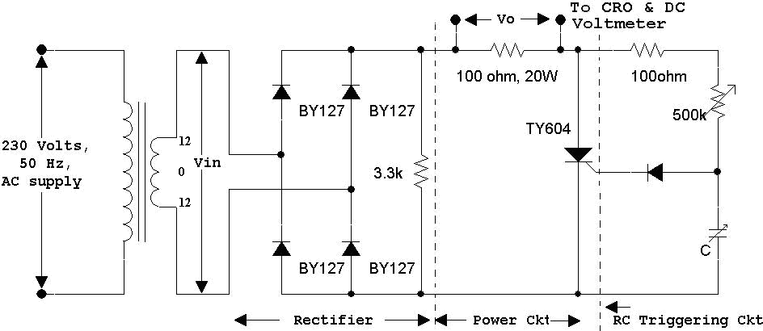

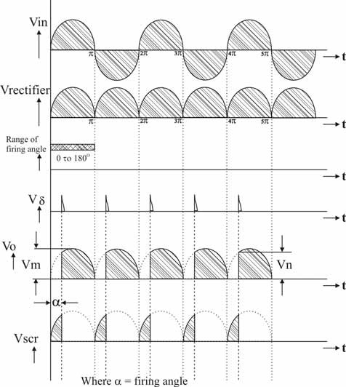**Waveforms:-**

**Tabular Columns:- Half Wave Rectifier**

|  |  |  |  |  |  |  |
| --- | --- | --- | --- | --- | --- | --- |
| Sl. No. | Vn | Vm | (<90O) | (>90O) | Vodc | Voth |
|  |  |  | α  sin-1 ( Vn / Vm ) | α  180  sin-1 ( Vn / Vm ) |  |  |
|  |  |  |  |  |  |  |

**Full Wave Rectifier**

|  |  |  |  |  |  |  |
| --- | --- | --- | --- | --- | --- | --- |
| Sl. No. | Vn | Vm | (<90O)  α  sin-1( Vn / Vm) | (>90O)  α  180  sin-1( Vn / Vm ) | Vodc | Voth |
|  |  |  |  |  |  |  |

**Viva Questions: -**

1. Explain the working operation of the circuit?
2. What are the limitations of R triggering circuit?
3. What are the limitations of RC triggering circuit?
4. Mention different methods of triggering SCR?
5. Why gate triggering is preferred?

……………………………….………………… Signature of the staff-in-charge

##### CIRCUIT DIAGRAM: -

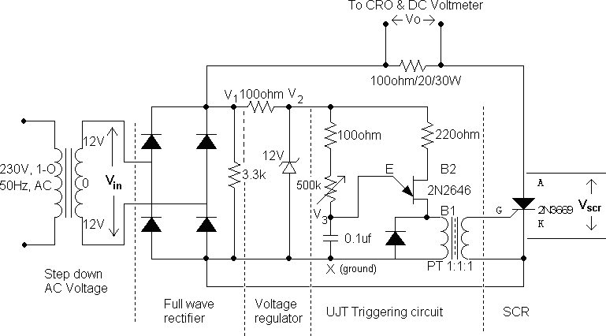

**Base Diagrams: -**

**SCR-TY604** **UJT: -2N2646** **Diode: - BY127**

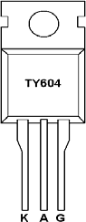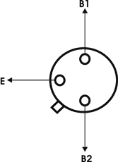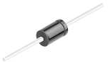

**Pulse Transformer**

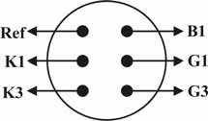

**Experiment No: 3** **DATE:**  **/**  **/**

**U. J. T.** **Triggering of S. C. R**

**AIM: -** To study the performance & waveforms of U.J.T triggering of S.C.R.

##### APPARATUS REQUIRED: -

SCR-TY604, Power supplies, Wattage Resistors, Ammeter, Voltmeter, UJT- 2N2646, Pulse Transformer, etc.,

##### PROCEDURE: -

1. Connections are mode as shown in the circuit diagram
2. By varying a resistance R gradually in step by step, note down the corresponding values of Vn & Vm from CRO and VOdc from D.C voltmeter. The readings are tabulated in the tabular column.
3. If firing angle ranges from 0 to 900, then firing angle can be calculated from

1 (Vn

####   Sin

V

m

#### in deg rees

If firing angle ranges from 900 to 1800, then firing angle can be calculated by using a formula,

1 ( *Vn*

**  180 *Sin* ⎜ ⎟

*Vm*

*in* deg*rees*

1. The conduction angle  can be calculated by using a formula,

= 180 - 

1. The current & power is calculated by

Idc

 Vdc

#### R

Amps

V 2

Pdc  dc Watts R

respectively

1. A graph of Vdc v/s , Vdc v/s , Idc v/s , Idc v/s , Pdc v/s  , and Pdc v/s 

are to be plotted on a graph sheet.

##### IDEAL WAVEFORMS: -

**Tabular Column: -**

|  |  |  |  |  |  |  |  |  |  |  |  |  |
| --- | --- | --- | --- | --- | --- | --- | --- | --- | --- | --- | --- | --- |
|  | FROM C.R.O | | | | | | | |  |  |  |  |
| Sl. No | 0 TO 900 | | | | 900 TO 1800 | | | | VDC  (Vload) volts | Idc = Vdc/R A | Pdc =  Vd 2/R c  Watts | Voth |
| Vn volts | Vm volts | ο  α  Sin1 ⎛ Vn ⎞    Vm | =180- | Vn volts | Vm volts | V ο  α  180  Sin1 n  Vm | = 180- |
|  |  |  |  |  |  |  |  |  |  |  |  |  |

1. For given frequency, the value of R can be calculated by using a formula,

#### T  2.303RC.log 1

*R*  *T*

#### 2.303*C*.log

10 1  

1 

10 1 **

When C = 0.1 mF & N = Intrinsic stand off ratio = 0.67

1. This value of R is set in the circuit, Step No S 3. 4. 5. & 6. are repeated and waveforms are observed at different points as shown.
2. Compare Voth with VoPractical where

Voth

 Vm 1  cos 

#### 

##### VIVA QUESTIONS: -

1. Explain the working operation of U.J.T. triggering circuit waveforms?
2. Why U.J.T. Triggering circuit is superior when compared to R & RC triggering circuit?
3. What is the use of pulse transformer?
4. Explain the design part of UJT?
5. Write equivalent circuit of UJT and show that Vpeak = Vemitter = V+VBB.
6. Why do we require turn-on circuits for thyristors?
7. Why do we require turn-off circuits for thyristors?
8. Comment on Forced & Natural Commutation techniques.

…………………………………………………. Signature of the staff-in-charge

##### CIRCUIT DIAGRAM: -

**Half Wave Rectifier**

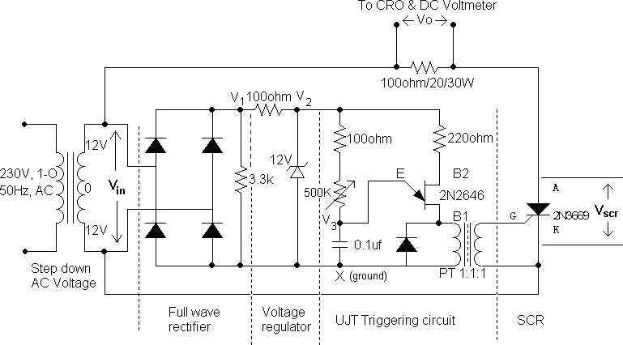

**Full Wave Rectifier**

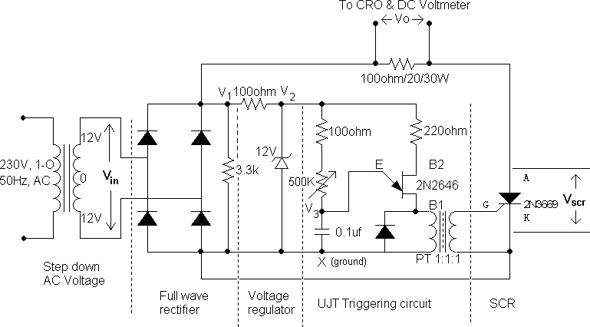

**Experiment No: 4** **DATE:**  **/**  **/**

**U. J. T.** **Triggering for HWR & FWR**

**AIM: -** To study the performance & waveforms of U.J.T triggering of S.C.R.

##### APPARATUS REQUIRED: -

SCR-TY604, Power supplies, Wattage Resistors, Ammeter, Voltmeter, UJT- 2N2646, Pulse Transformer, etc.,

##### PROCEDURE: -

1. Connections are mode as shown in the circuit diagram
2. By varying a resistance R gradually in step by step, note down the corresponding values of Vn & Vm from CRO and Vdc from D.C voltmeter. The readings are tabulated in the tabular column.
3. If firing angle ranges from 0 to 900, then firing angle can be calculated from

1 Vn 0 0

  Sin vV in degrees.If firing angle ranges from 90 to 180 ,

m

then firing angle can be calculated by using a formula,

1 Vn

####   180  Sin vV in deg rees

m

1. The conduction angle  can be calculated by using a formula,= 180 - 
2. The current & power is calculated by

I  Vdc Amps

dc R

V 2

Pdc  dc Watts R

respectively

1. A graph of Vdc v/s , Vdc v/s , Idc v/s , Idc v/s , Pdc v/s  , and Pdc v/s 

are to be plotted on a graph sheet.

##### IDEAL WAVEFORMS: -

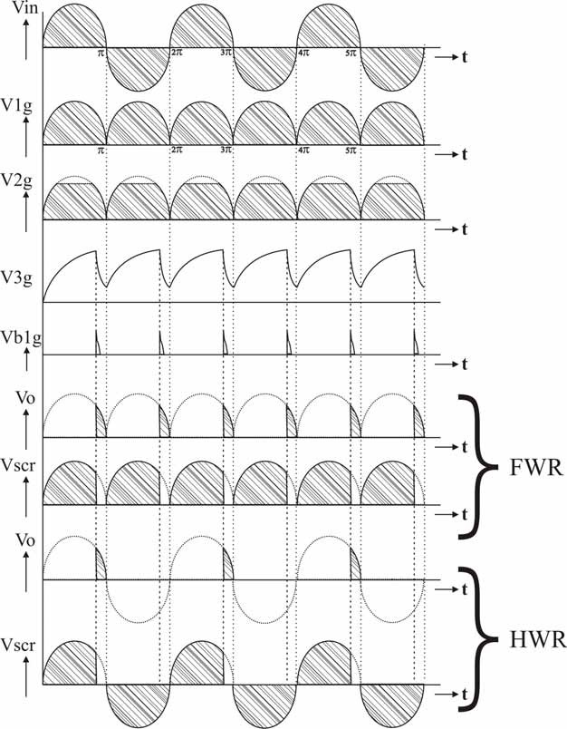

1. For given frequency, the value of R can be calculated by using a formula,

#### T  2.303RC.log 1

*R*  *T*

#### 2.303*C*.log

10 1  

1 

10 1 **

When C = 0.1 mF & N = Intrinsic stand off ratio = 0.67

1. This value of R is set in the circuit, Step No S 3. 4. 5. & 6. are repeated and waveforms are observed at different points as shown.
2. The practical o/p voltage (Vo meter) is compared with Voth

*For HWR*, Voth

*For* F*WR*, Voth

 Vm 1  cos** *volts*whereV 

2** m

 Vm 1  cos** *volts*

**

2*Vin* rms

##### Graph: -

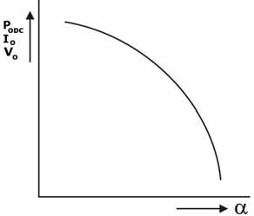 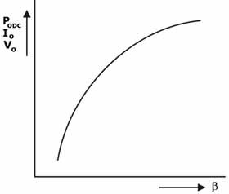

##### Tabular Column:- a) Half wave switches

|  |  |  |  |  |  |  |  |  |  |  |  |
| --- | --- | --- | --- | --- | --- | --- | --- | --- | --- | --- | --- |
| Sl.No | FROM C.R.O | | | | | | | | VDC  (Vload) volts | Idc = Vdc/R A | Pdc =  V 2/R  dc  Watts |
| 0 TO 900 | | | | 900 TO 1800 | | | |
| Vn volts | Vm volts | ⎛ V ⎞ο  α  Sin1 ⎜ n ⎟  ⎝ Vm ⎠ | =180-   | Vn volts | Vm volts | 180  ⎛ V ⎞ο  Sin1 ⎜ n ⎟  ⎝ Vm ⎠ | =180-   |
|  |  |  |  |  |  |  |  |  |  |  |  |

**Full wave switches**

|  |  |  |  |  |  |  |  |  |  |  |  |
| --- | --- | --- | --- | --- | --- | --- | --- | --- | --- | --- | --- |
|  | FROM C.R.O | | | | | | | |  |  |  |
| Sl. No | 0 TO 900 | | | | 900 TO 1800 | | | | VDC  (Vload) volts | Idc = Vdc/R A | Pdc =  V 2/R  dc  Watts |
| Vn | Vm | ⎛ V ⎞□    Sin1⎜ n ⎟  ⎝ Vm ⎠ | =180- | Vn | Vm | 180  ⎛ *V* ⎞*□*  *Sin*1 ⎜ *n* ⎟  ⎝ *Vm* ⎠ | =180- |
|  | volts | volts |  | volts | volts |  |  |  |  |
|  |  |  |  |  |  |  |  |  |  |  |  |

**Base Diagrams: -**

**SCR-TY604** **UJT: -2N2646** **Diode: - BY127**

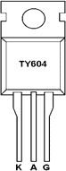 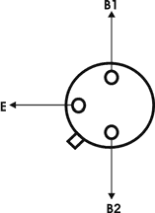 

##### VIVA QUESTIONS: -

1. Explain the working operation of U.J.T. triggering circuit waveforms?
2. Why U.J.T. Triggering circuit is superior when compared to R & RC triggering circuit?
3. What is the use of pulse transformer?
4. Explain the design part of UJT?
5. Write equivalent circuit of UJT and show that Vpeak = Vemitter = V+VBB.
6. Why do we require turn-on circuits for thyristors?
7. Why do we require turn-off circuits for thyristors?
8. Comment on Forced & Natural Commutation techniques.

…………………………………………………. Signature of the staff-in-charge

##### CIRCUIT DIAGRAM: -

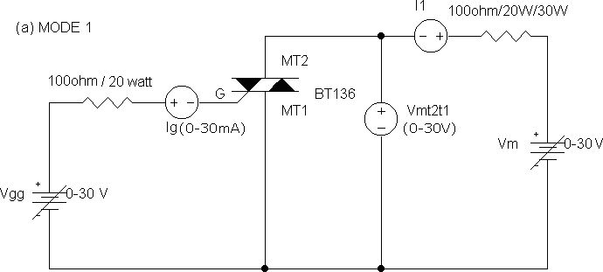

1 K  /1W

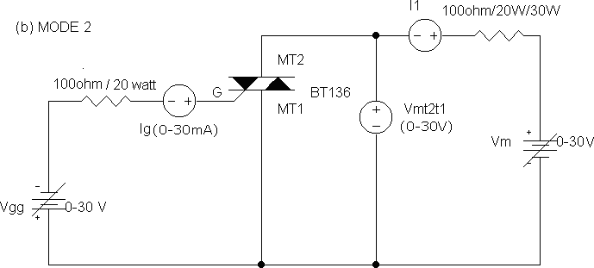

1 K  /1W

- 8 -

1 K  /1W

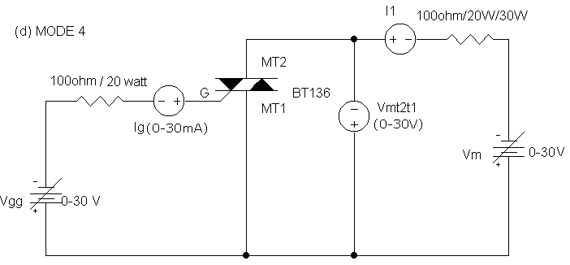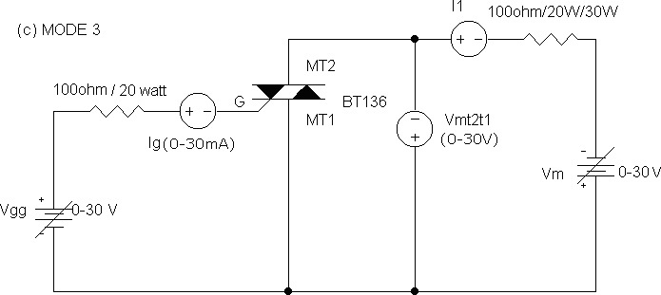

1 K  /1W

**Experiment No: 5** **DATE:**  **/**  **/**

**TRIAC Characteristics**

**Aim:** -

To study the v-1 characteristics of a TRIAC in both directions and also in different (1, 2, 3 & 4) modes op operation and determine break over voltages, holding current, latching current and comment on sensitivities.

##### Apparatus required: -

TRIAC – BT 136, power supplies, wattage resistors, ammeter, voltmeter, etc.,

##### Procedure: - I mode

1. Connections are made as shown in the circuit diagram (a)
2. The value of gate current ig is set to convenient value by adjusting vgg.
3. By varying the supply voltage Vm gradually in step-by-step, note down the corresponding values of Vmt2t1 and i1. Note down Vmt2t1 and i1 at the instant of firing of TRIAC and after firing (by reducing the voltmeter ranges and increasing the ammeter ranges) then increase the supply voltage Vmt2mt1 and i1.
4. The point at which TRIAC fires gives the value of break over voltage vbo1
5. A graph of vmt2t1 v/s i1 is to be plotted.
6. The gates supply voltage. Vgg is to be switched off
7. Observe the am meter reading by reducing the supply voltage vmt. The point at which the ammeter reading suddenly goes to zero gives the value of holding current ih.

##### mode: -

* 1. Connections are made as shown in the circuit diagram (b)
  2. The gate current is set as same value as in i-mode
  3. Repeat the step no. s 3, 4, 5, 6, & 7 of I-mode

##### Characteristic curve: - Normal Method

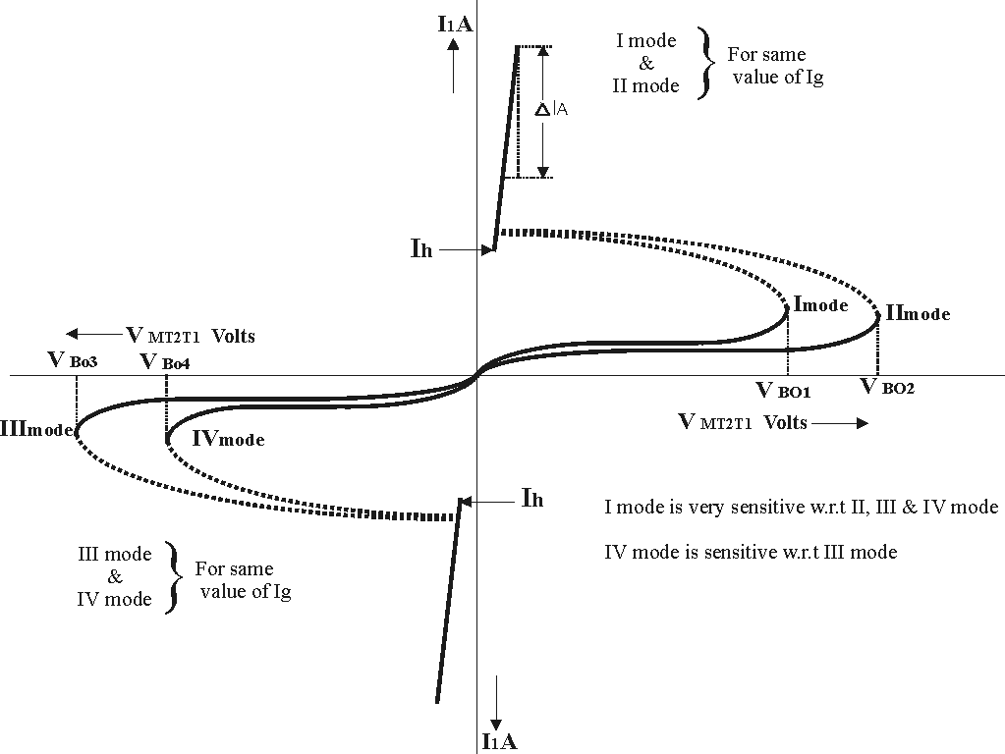

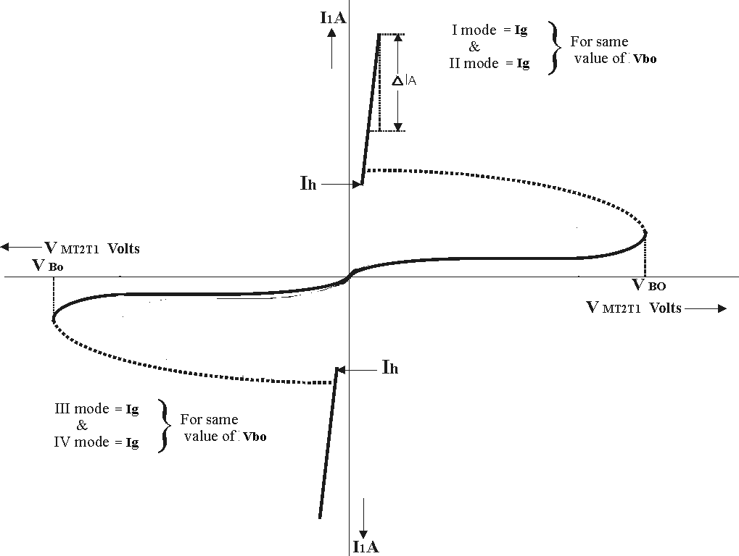**Alternate Method**

1. **mode**
   1. Connections are mode as shown in the circuit diagram (c).
   2. Step no. s 2, 3, 4, 5, 6, & 7 are to be repeated as in i-mode.

##### mode

* 1. Connections are mode as shown in the circuit diagram (d)
  2. Repeat the step no. s 2, 3, 4, 5, 6, & 7 of i-mode.

##### Alternate Method: -

1. Connections are made as shown in the circuit diagram
2. Adjust the value of Ig to zero or some minimum value
3. By varying the voltage Vmt2mt1 from 0 to 10 volts with a step of 2 volts, note down corresponding values of I1
4. Now apply the gate voltage gradually, until SCR fires, then note down the values of Ig and also the values of I1 and Vmt2mt1.
5. Increase Vm to some value and note down I1 and Vmt2mt1.
6. Reduce gate voltage to zero, observe ammeter reading by reducing Vm which gives the values of Ih (holding current) at the point at which, current suddenly drops to zero
7. Repeat the steps 2, 3, 4, 5 & 6 for different values of break over voltages
8. Plot a graph of Vmt1mt2 v/s I1
9. Repeat the steps 1, 2, 3, 4, 5, 6 & 7 for different modes 10.Compare sensitivity of TRIAC and comment on sensitivities.
10. Refer same design procedure for selection of RL and Rg as that of SCR.
11. Follow the same procedure as that of SCR experiment to find latching current.

##### Tabular column: -

**I-mode** **II-mode**

**i g =** **ma** **I g =** **ma**

|  |  |  |
| --- | --- | --- |
| Sl.no | VTRIAC volts | ITRIAC ma |
|  |  |  |

|  |  |  |
| --- | --- | --- |
| Sl.no | VTRIAC volts | ITRIAC ma |
|  |  |  |

##### mode IV-mode

**i g =** **ma** **I g =** **ma**

|  |  |  |
| --- | --- | --- |
| Sl.no | VTRIAC volts | ITRIAC ma |
|  |  |  |

|  |  |  |
| --- | --- | --- |
| Sl.no | VTRIAC volts | ITRIAC ma |
|  |  |  |

##### Base diagram of BT136:

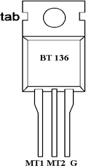

**Viva questions: -**

* 1. Explain the different working modes of operations of a TRIAC?
  2. Why i-mode is more sensitive among all modes?
  3. What are the applications of TRIAC
  4. Compare SCR, TRIAC & DIAC
  5. Why I & II modes are operating in Ist quadrant and III & IV modes are operating in IIIrd quadrant?

………………………….…………………….. Signature of the staff with date

##### CIRCUIT DIAGRAM: -

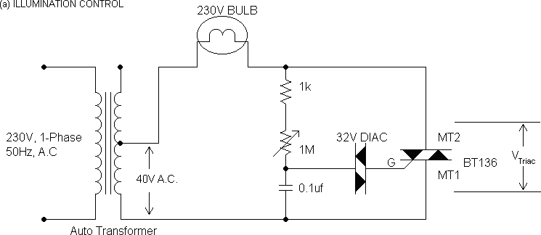

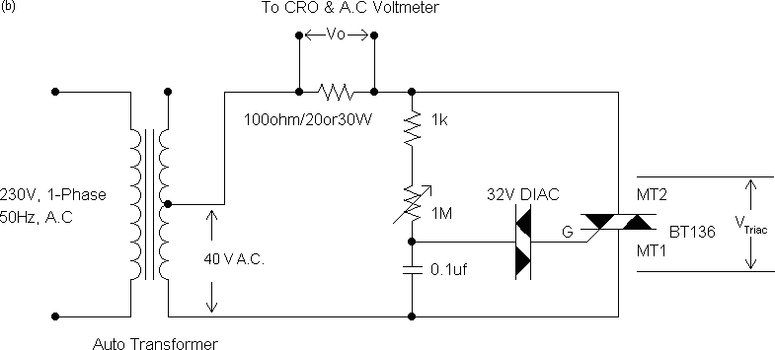

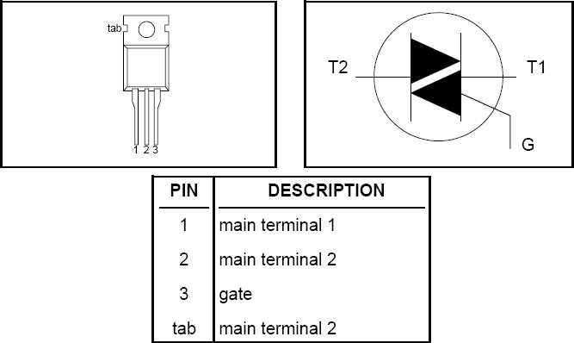

##### Experiment No: 6 DATE: / /

**AC Voltage Control by using TRIAC-DIAC Combination**

**AIM:** -

1. To study the AC voltage control by using TRIAC-DIAC combination

##### APPARATUS REQUIRED: -

TRIAC, DIAC, supply voltage, wattage resistors, Ammeter, Voltmeter, etc,.

##### PROCEDURE: - A.

1. Connections are mode as shown in the circuit diagram (a)
2. By varying the variable resistance R1 in step by step, observe the variation of intensity of light.

##### B.

1. Connections are mode as shown in the circuit diagram (b)
2. By varying the resistance R, in step-by-step note down the corresponding vales of Vn & Vm from C.R.O. and Va.c from A.C. voltmeter the readings are tabulated in the tabular column
3. If delay angle ranges from 0 To 900, then firing angle can be calculated

1 Vn 0 0

from α  Sin

vV in degrees . If firing angle ranges from 90 To 180

then

m⎠

1 Vn

can be calculated by using a formula,

α  180  Sin

⎜ ⎟ in degrees

V

V m

1. The conduction angle B can be calculated by using a formula,

= 180 -  in degrees

1. The current can be calculated by

Iac

 Vac

#### R

1. A graph of Iac v/s , Vac or load voltage v/s  are to be plotted
2. Compare V

oeter

with V

oth

where

Voth

 Vin rms

### Tabular Column: -

1 ⎛    sin 2 ⎞

❐ ⎜

⎝

2

⎟

⎠

|  |  |  |  |  |  |  |  |  |  |  |  |  |
| --- | --- | --- | --- | --- | --- | --- | --- | --- | --- | --- | --- | --- |
| Sl. No | FROM C.R.O | | | | | | | | VDC  (Vload) volts | Idc =  Vdc/ R  A | Vin Volt  s | Speed rpm |
| 0 TO 900 | | | | 900 TO 1800 | | | |
| Vn  volts | Vm  volts | V □    Sin1  n  Vm | =180-   | Vn  volts | Vm  volts | L = 180 -  *V□*  *Sin*1 *n*  *Vm* | =180-   |
|  |  |  |  |  |  |  |  |  |  |  |  |  |

##### Waveforms:-

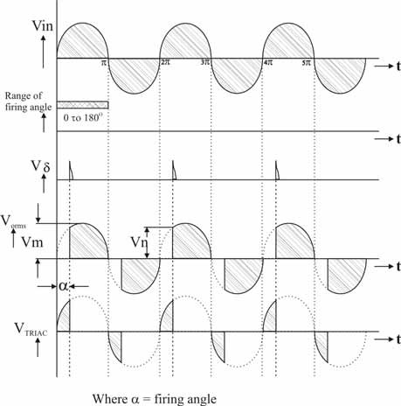

**VIVA QUESTIONS: -**

1. Explain the features of TRIAC?
2. Explain the working operation of illumination control & various voltage output waveforms by using TRIAC?
3. Compare S.C.R, DIAC & TRIAC?
4. What is universal motor?
5. Comment on the different graphs of this experiment?
6. Mention the applications of TRIAC?

……………………………………………….. Signature of the staff with date

**Experiment No: 7** **DATE:**  **/**  **/**

##### Pulse Width Modulation techniques

PWM is a technique that is used to reduce the overall harmonic distortion (THD) in a load current. It uses a pulse wave in rectangular/square form that results in a variable average waveform value f(t), after its pulse width has been modulated. The time period for modulation is given by T. Therefore, waveform average value is given as

##### T

**y=(1/T) ∫ f(t)dt**

##### 0

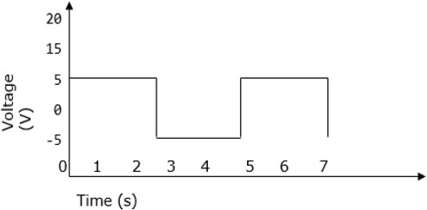

Sinusoidal Pulse Width Modulation

In a simple source voltage inverter, the switches can be turned ON and OFF as needed. During each cycle, the switch is turned on or off once. This results in a square waveform. However, if the switch is turned on for a number of times, a harmonic profile that is improved waveform is obtained.



The sinusoidal PWM waveform is obtained by comparing the desired modulated waveform with a triangular waveform of high frequency. Regardless of whether the voltage of the signal is smaller or larger than that of the carrier waveform, the resulting output voltage of the DC bus is either negative or positive.

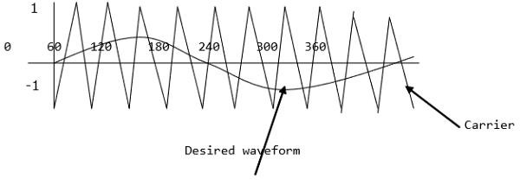

The sinusoidal amplitude is given as Am and that of the carrier triangle is give as Ac.

For sinusoidal PWM, the modulating index m is given by Am/Ac.

Modified Sinusoidal Waveform PWM

A modified sinusoidal PWM waveform is used for power control and optimization of the power factor. The main concept is to shift current delayed on the grid to the voltage grid by modifying the PWM converter. Consequently, there is an improvement in the efficiency of power as well as optimization in power factor.



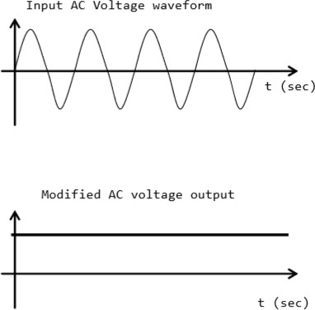

### Multiple PWM

The multiple PWM has numerous outputs that are not the same in value but the time period over which they are produced is constant for all outputs. Inverters with PWM are able to operate at high voltage output.

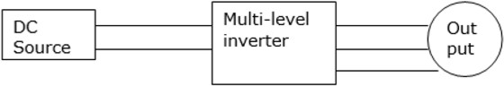

The waveform below is a sinusoidal wave produced by a multiple PWM

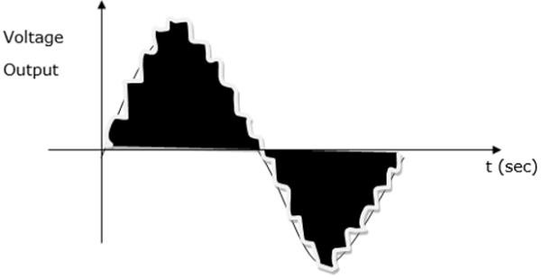



………………………………………………..

Signature of the staff with date

**Experiment No: 8** **DATE:**  **/**  **/**

**Single Phase Dual Converter with R & RL Loads**

To study the operation of a single phase dual converter in circulating and non – circulating current modes for various types of loads.

**APPARATUS:**

|  |  |  |
| --- | --- | --- |
| ***S.no*** | ***Description*** | ***Quantity*** |
| **1** | Dual Converter Kit | 1 |
| **2** | Unearthed C.R.O | 1 |
|  |  | 1 |
| **3** | Connecting probes |  |
| **4** | Loading resistor 50Ω/8A | 1 |
|  | Inductor with mid point |  |
| **5** | 100 – 0 - mH | 1 |
| **6** | Inductor 25mH | 1 |

**PROCEDURE**

DUAL CONVERTER WITH NON - CIRCULATING CURRENT MODE

* + P – Converter is ON & N converter is OFF:

1. Make the connections as per the power circuit shown in the circuit diagram.
2. Connect the trigger pulses to the gate and cathode terminals of SCR’s from G & K terminals of the firing circuit module.
3. Before switching on the supply ensure that switching sequence is followed.
4. Connect CRO across the load.
5. Apply 10V AC input voltage using isolation transformer.
6. Make P – Converter ON & OFF the N Converter in the firing angle circuit module.
7. Observe and plot the variation in the output voltage waveform across the load terminals with the help of CRO.
8. Repeat step 7 by varying firing angle pulses in sequence.

##### Circuit Diagram:

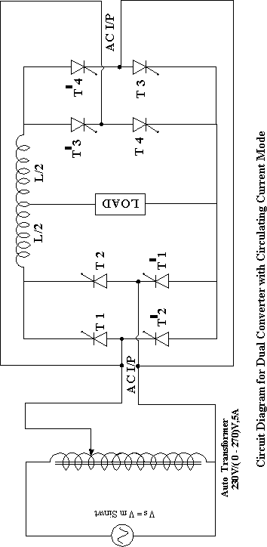

* N – Converter is ON & P converter is OFF:

1. Make the connections as per the power circuit shown in the circuit diagram.
2. Connect the trigger pulses to the gate and cathode terminals of SCR’s from G & K terminals of the firing circuit module.
3. Before switching on the supply ensure that switching sequence is followed.
4. Connect CRO across the load.
5. Apply 10V AC input voltage using isolation transformer.
6. Make N – Converter ON & OFF the P Converter in the firing angle circuit module.
7. Observe and plot the variation in the output voltage waveform across the load terminals with the help of CRO.
8. Repeat step 7 by varying firing angle pulses in sequence.

* **DUAL CONVERTER WITH CIRCULATING CURRENT MODE**

1. Make the connections as per the power circuit shown in the circuit diagram
2. Connect the trigger pulses to the gate and cathode terminals of SCR’s from G & K terminals of the firing circuit module.
3. Before switching on the supply ensure that switching sequence is followed.
4. Connect CRO across the load.
5. Apply 10V AC input voltage using isolation transformer.
6. Make N – Converter ON & OFF the P Converter in the firing angle circuit module.
7. Observe and plot the variation in the output voltage waveform across the load terminals with the help of CRO.
8. Repeat step 7 by varying firing angle pulses in sequence.

**PRECAUTUIONS:**

* 1. Identify the terminals of the SCR carefully before connecting the circuit.
  2. Use an unearthed CRO.
  3. Before switching ON the supply see that the firing angle knob and auto transformer are in minimum position.
  4. With outcentre tapped inductor between the two converters don’t operate in circulating current mode.

**OBSERVATIONS:**

**Dual Converter with Non - Circulating Current Mode**

|  |  |  |  |  |  |
| --- | --- | --- | --- | --- | --- |
| SNo | Firing Angle | P – ON & N - OFF | | N – ON & P - OFF | |
| Vo (Theoretical) | Vo  (Practical) | Vo  (Theoretical) | Vo  (Practical) |
|  |  |  |  |  |  |

*MODEL GRAPHS:*

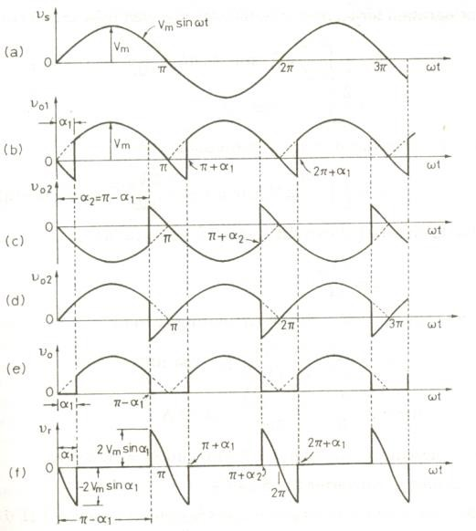

OUTPUT WAVE FORMS:

Result:……………………………………….. Signature of the staff with date



**Experiment No: 09** **DATE:**  **/**  **/**

**SINGLE PHASE CYCLO CONVERTER**

**AIM:**To construct a single phase cycloconverter circuit and study its performance.

##### APPARATUS:

230V input 150V-0-15V output AC step down transformer (provided within the unit), cycloconverter power circuit with firing circuit, loading rheostat 100 ohms/2A. Digital multimeter, CRO,Path cards etc.

##### CIRCUIT DIAGRAM:

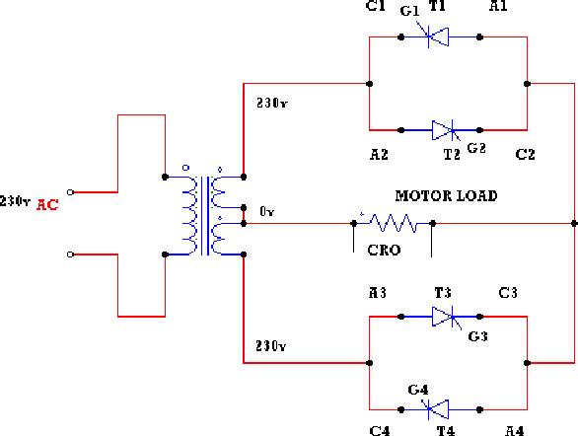

**THEORY:**

A cycloconverter converts input power at one frequency to output power at a different frequency with one stage conversion. cycloconverter is used in speed control of high power AC drives ,induction heating etc.



The circuit shown is for obtaining single phase frequency divided output from a single phase AC input. One group of SCR’s produces positive polarity load voltage and other group produces negative half cycle of the output. SCR’s T1 and T3 of the positive group are gated together depending on the polarity of the input, only one of them will conduct, when upper AC terminal is positive with respect to O, SCR T1will conduct and when upper AC terminal is negative, SCR T3will conduct thus in both half cycles of input, the load voltage polarity will be positive by changing firing angle, the duration of conducting of each SCR (and there by the magnitude of the output voltage) can be varied. For the sake of simplicity it is assumed that the load is positive. Then each SCR will have a conduction angle of (π –α) and turn off by natural commutation at the end of every half cycle of the input. At the end of each half period of the output, the firing pulses to the SCR’s of the positive group will be stopped and SCR’s T2 and T4 of the negative group will be fired.

##### PROCEDURE:

**SINGLE PHASE CYCLOCONVERTER**

* + 1. The connections are made as shown in the circuit of single phase cycloconverter with Motor Load with divided by 2 frequency.
    2. The gate cathode terminals of the thyristors are connected to the respective points on the firing module.
    3. Check all the connections and confirm connections made are correct before switching on the equipments.
    4. Switch ON unit.
    5. The output wave forms are seen on a CRO.
    6. The firing angle is varied and AC output voltage across the load is noted.
    7. A graph of Vacverses load voltage is plotted.
    8. Repeat the above procedure for divided by four frequency.

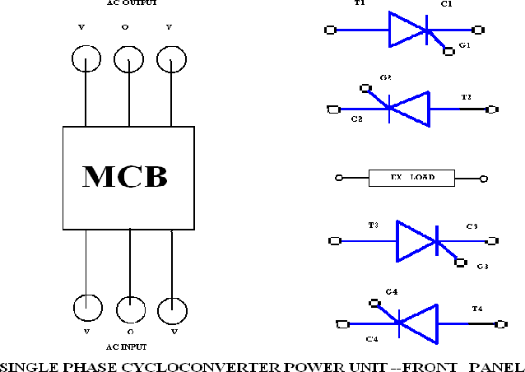

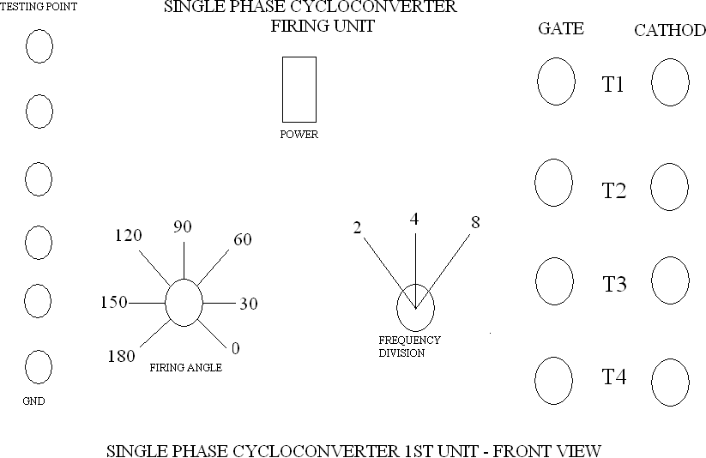



##### EXPERIMENTAL OBSERVATIONS:

Frequency divided by 2

|  |  |  |  |
| --- | --- | --- | --- |
| **Sl.No** | **Firing angle α(in degrees)** | **Load voltage in volts using AC voltmeter in volts** | **RPM** |
| 1. | 180o |  |  |
| 2. | 150o |  |  |
| 3. | 120o |  |  |
| 4. | 90o |  |  |
| 5 | 60o |  |  |
| 6 | 30o |  |  |
| 7 | 0o |  |  |

#### Output waveforms



##### RESULT:

……………………………………………..

Signature of the staff with date

**Experiment No: 10** **DATE:**  **/**  **/**

**Speed Control of Single Phase Induction Motor**

**Aim: -**

To study speed control of Induction motor and plot speed v/s .

##### Apparatus required: -

Module, TRIAC, Induction Motor, etc.,

##### Procedure: -

1. Connections are made as shown in the circuit diagram.
2. Firing angle  is varied in steps gradually, note down corresponding speed of the induction motor using Tachometer and tabulate.
3. A graph of  v/s speed is plotted.

##### Result: -

Speed control of Induction Motor is studied and a graph of  v/s speed is plotted.

………………………….…………………….. Signature of the staff with date

# Data Sheets

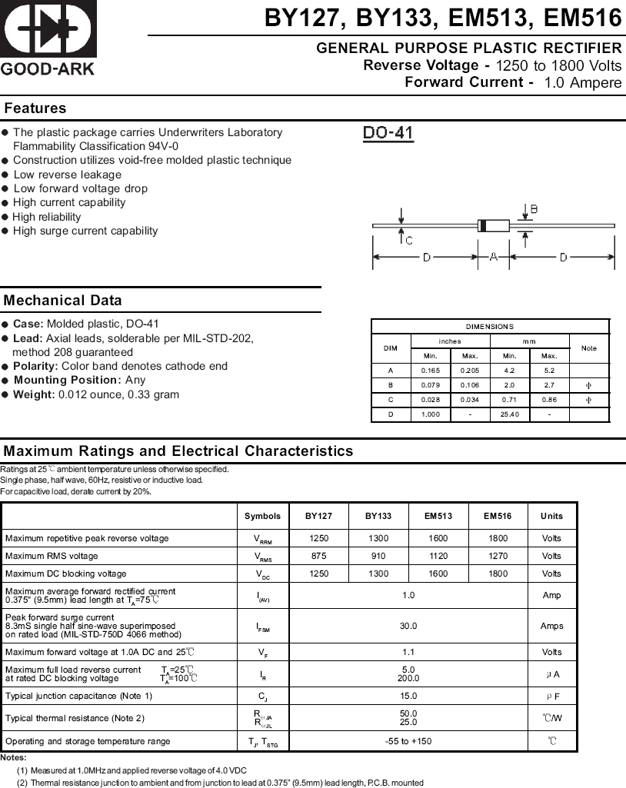



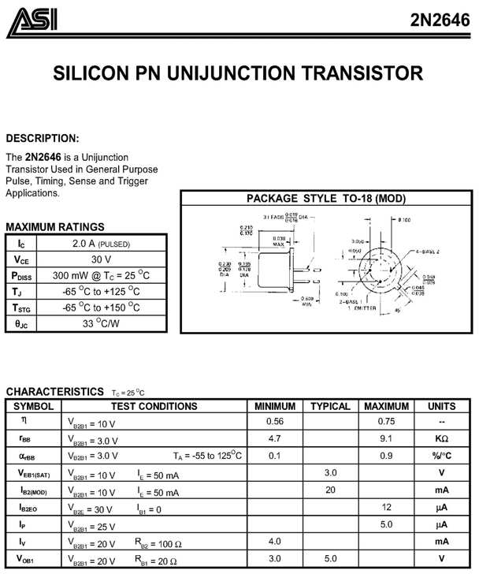

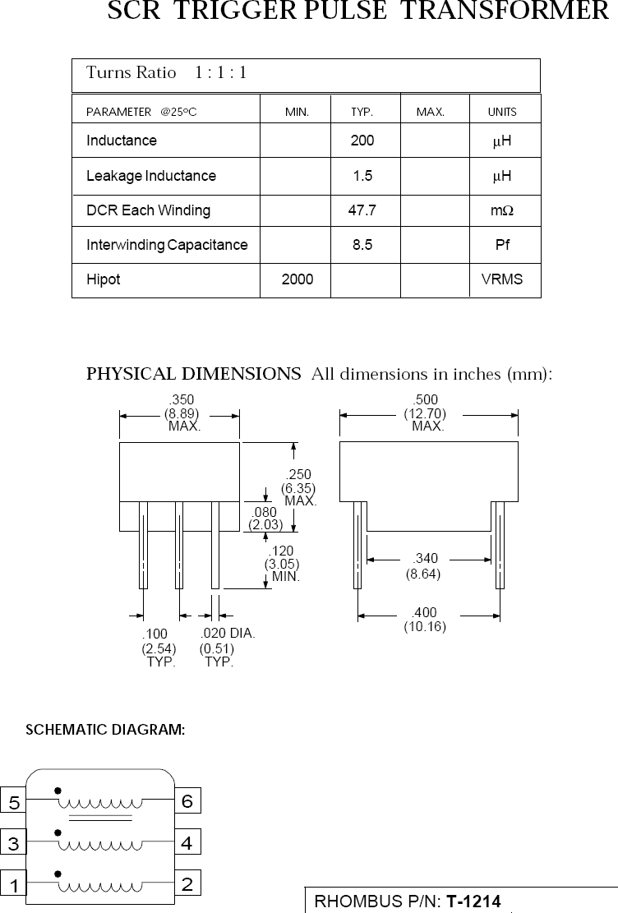

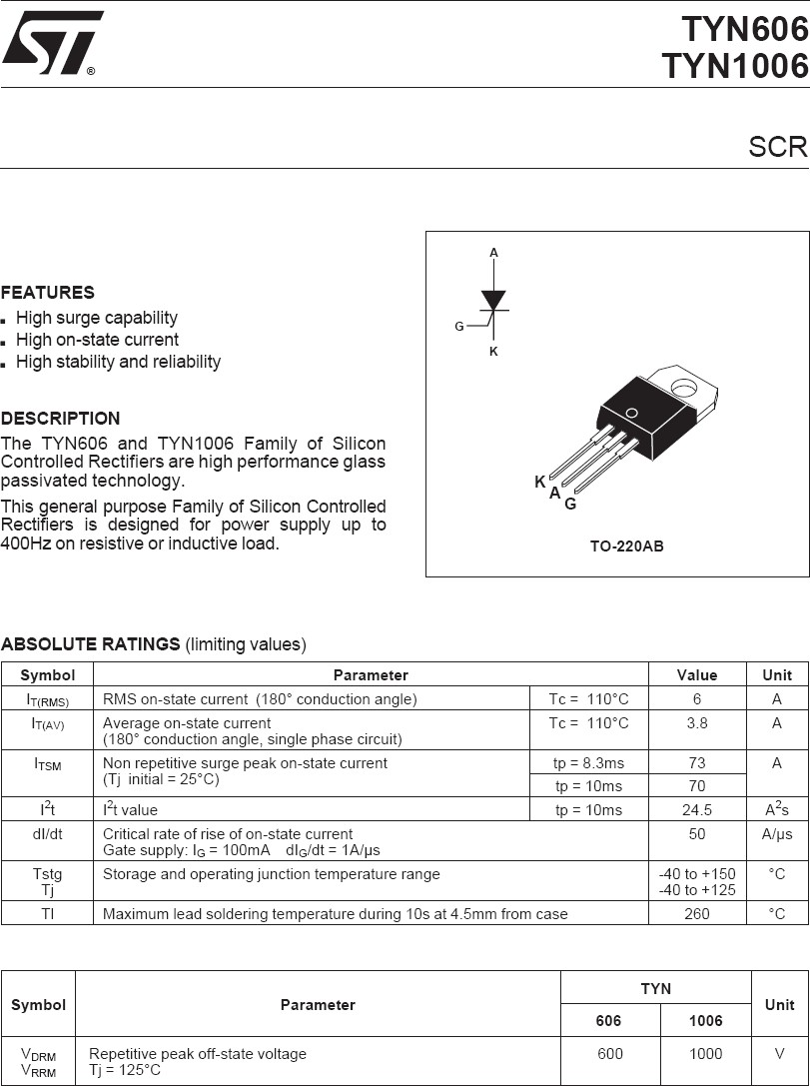

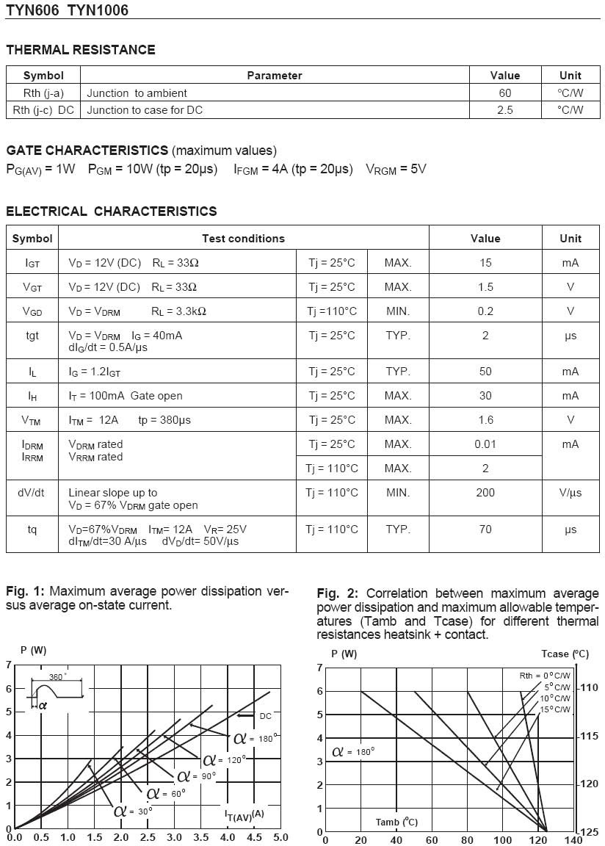

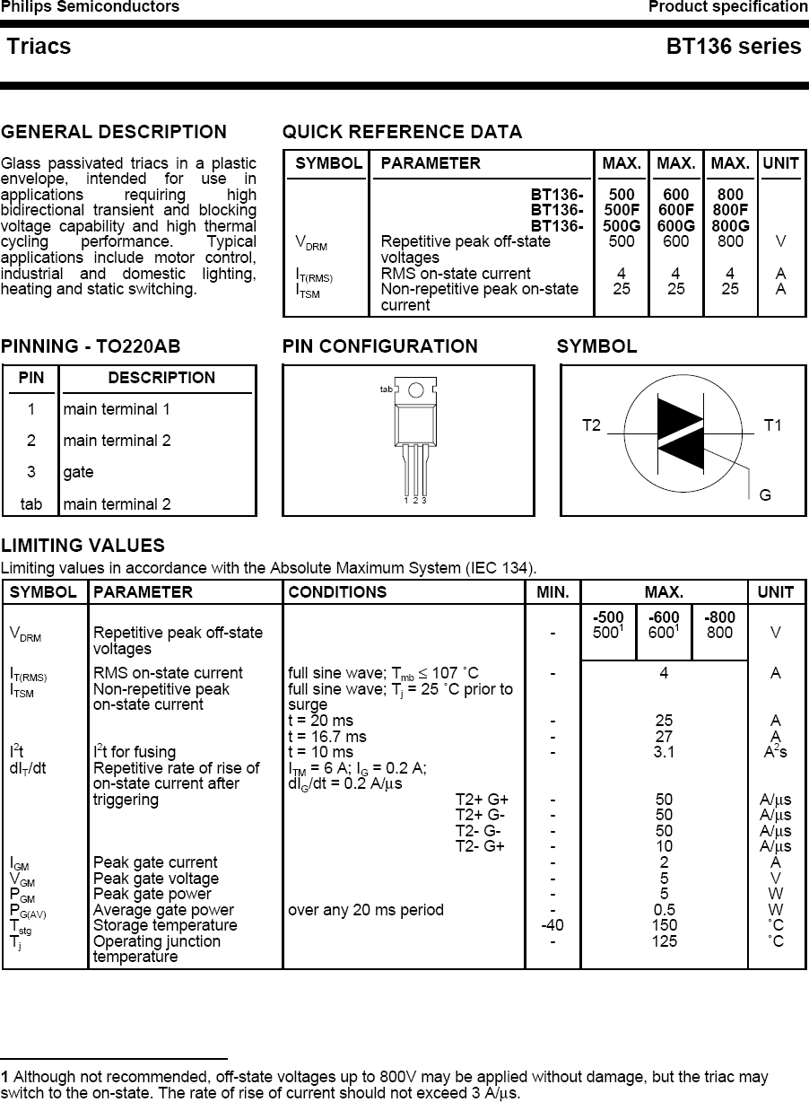

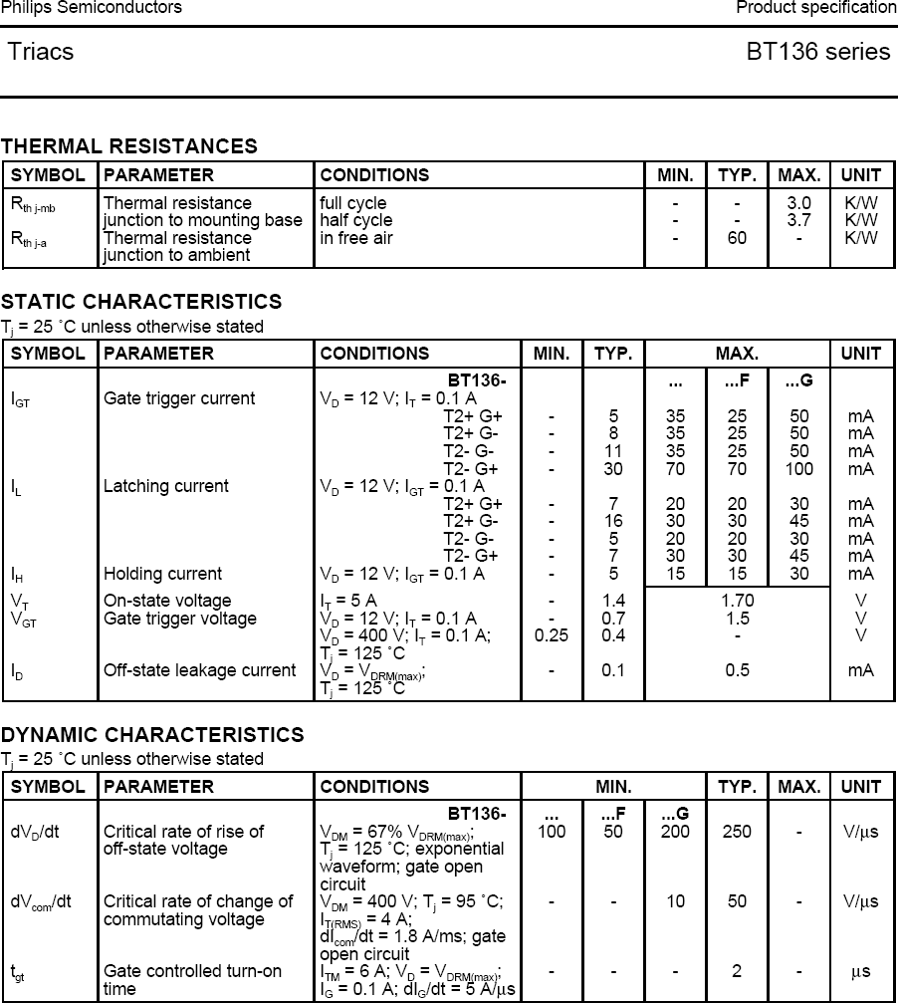

##### Power Electronics Lab manual MECA

